**Abstract**

Coronavirus disease 2019 (COVID-19) is a newly-identified infectious disease that has rapidly spread throughout the world with rising fatalities with declaration by the World Health Organization as the pandemic. Online consultations have been shown to alleviate the pandemic with our study aims to demonstrate whether online consultation can be a solution for acute health crises. The number of online consultations has increased with diagnosis of upper respiratory tract infection, psychological conditions, COVID- 19-related investigations and interventions. However, recent policy changes during the COVID-19 pandemic have reduced barriers to telehealth access and have promoted the use of telehealth as a way to deliver acute, chronic, primary and specialty care Many professional medical societies endorse telehealth services and provide guidance for medical practice in this evolving landscape. Telehealth can also improve patient health outcomes. The increased online consultations met the increased demand of the relevant clinical services and reduced the overwhelming hospital presentations, thus decreasing the potential COVID- Symptoms 19 spread inside the major tertiary hospital and sparing the resources for acute crisis management.

The factors we needed to include are:

Provide online health services to patient

Medicines prescribed to each patient

Bill details

Patients number of visits through online/offline

Hospital details to patients

Number of beds availability

Blood availability

Oxygen supply

Plasma supply

Recovered patient plasma list

Online appointments - Time slots, Availability of doctors

Availability and searching of drugs

Any queries of patients

Food which has to be eaten by patients.

**TABLE OF CONTENT**

* 1. Abstract 1
  2. Introduction and Implementation details 3
  3. Methodology 5
  4. Outcomes 10
  5. Conclusion 18
  6. Project Outcomes 19

References

**INTRODUCTION**

The developing world faces many health problems i.e. HIV/AIDS, Malaria, Tuberculosis, recently covid also threatened the health and lives of people. Lack of infrastructure and trained man power are considered important barriers in providing proper treatment and medical care for diseases. Millions of lives were lost during the pandemic. Losing the lives due to severe conditions is one reason and on the other hand losing lives due to the deepening crisis of doctors and infrastructure is even worse. We aimed to help doctors as well as patients. Here no patient has a need to meet a doctor. In some cases, he can get all the facilities that he needs in a few seconds, just by sending a message for an appointment or getting a prescription from a doctor. Our objective is to help patients with the availability of doctors online through appointments. Our project deals with appointments, reminders, to ease the process of taking appointments, provide an easy interface to users and doctors alike, and store the information securely. If the severity of the patient is less, he/she can meet the doctor online.

**Requirements**

**SOFTWARE /HARDWARE REQUIREMENTS**

**SOFTWARE:**

**FRONT END**

1.HTML

2.CSS

**BACK END**

1.SQL

2.PHP

**HARDWARE:**

Any android device can be used.

**Methodology**

When the Corona patients open our webpage they will get access to the following.

• Doctor’s availability

• Appointments of a particular doctor at a specific time.

• Prescription to a patient from a specific doctor.

• Alarms at particular time for medicines

• Quarantine center list and Vaccination center (advance booking)

• Plasma donors list

**Existing system & proposed system:**

**Existing System:**

1.Unnecessary usage of beds which leads to shortage of beds

2.Shortage of PPE kits

3.Difficulty in maintaining adequate staff

4.Patients who are suffering with other diseases in hospital may get affected

5.Disease may spread while traveling.

**Proposed system:**

Online interaction

To increase social distancing

List of Donors

Economically beneficial

**NEED**

* Help to prevent the spread of covid-19
* Level of risk to staffs may decrease
* Information to covid patients without physical interaction
* Hospitals which have inadequate services
* People who are unaware about the doctors availability
* Easy access to specialists
* Medical access for people in rural areas

**Implementation details**

Hospital Services to covid patients online project will be implemented as a web application using the HTML, CSS, Js and SQL.

It is a web-based application built with SQL to store, retrieve, and analyze information related to administrative administration inside a system that keeps track of all donors, Quarantine centers and doctors information.

The purpose of a web browser (Chrome, Edge, Firefox, Safari) is to read HTML documents and display them correctly.

A browser does not display the HTML tags, but uses them to determine how to display the document.

Since the early days of the World Wide Web, there have been many versions of HTML.

**HTML**

* HTML stands for Hyper Text Markup Language
* HTML is the standard markup language for creating Web pages
* HTML describes the structure of a Web page
* HTML consists of a series of elements
* HTML elements tell the browser how to display the content
* HTML elements label pieces of content such as "this is a heading", "this is a paragraph", "this is a link", etc.
* The <!DOCTYPE html> declaration defines that this document is an HTML5 document
* The <html> element is the root element of an HTML page
* The <head> element contains meta information about the HTML page
* The <title> element specifies a title for the HTML page (which is shown in the browser's title bar or in the page's tab)
* The <body> element defines the document's body, and is a container for all the visible contents, such as headings, paragraphs, images, hyperlinks, tables, lists, etc.
* The <h1> element defines a large heading
* The <p> element defines a paragraph

**Major Roles in the Application:**

1. **Patient**
2. **Doctor**
3. **Admin**

**Functions of the roles**

1. **Patient**

●  After opening the website, the patient sees the Application form to be filled to engage with the doctor.

●  Patients can select the doctors to their comfort.

●  Patients will know the availability of doctors, medicines.

●  Patients also know the updates about covid.

●  Patients can view the list of donors.

**2. Doctor**

* The Doctor  gets the notification about the pending patients list.
* Doctor will give suggestions through video conferences to patients.
* Give prescriptions which will be available to the patient anytime when they login.

**3.Admin**

●  After filling the application form, the data is stored and examined to provide further services.

●  Patients will get alarms periodically when they have to take medicines.

●  Our website shows the medicines available in the store.

●  Prescription is also provided in our website, so that it is recorded and can be viewed the previous visits and problems when needed.

●  Admins will also make updates frequently.

●  Admin can see the history of patients' visits and can also view their details.

●  Can View, Update, Delete Patient, doctors and donors profiles.

**ER DIAGRAM**

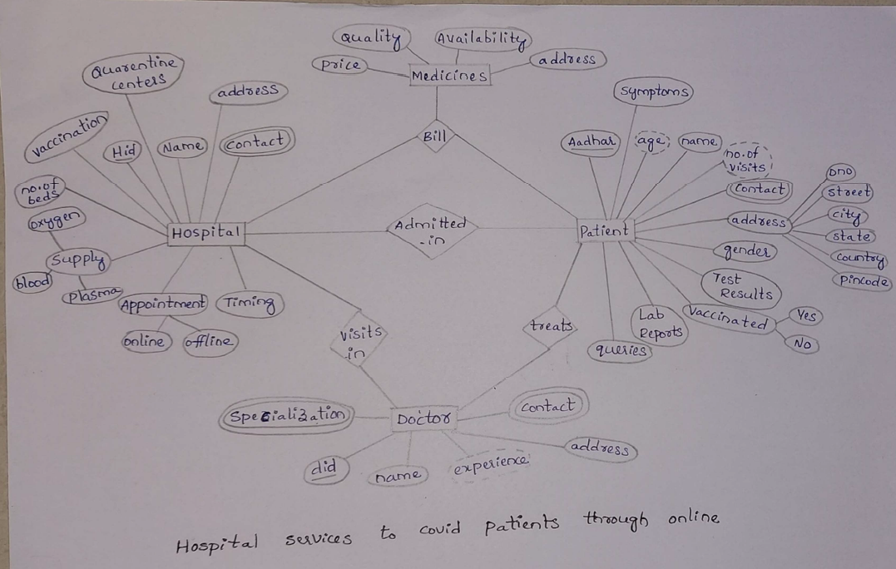

**OUTCOMES**

**Website creation:**

**Using html and CSS:**

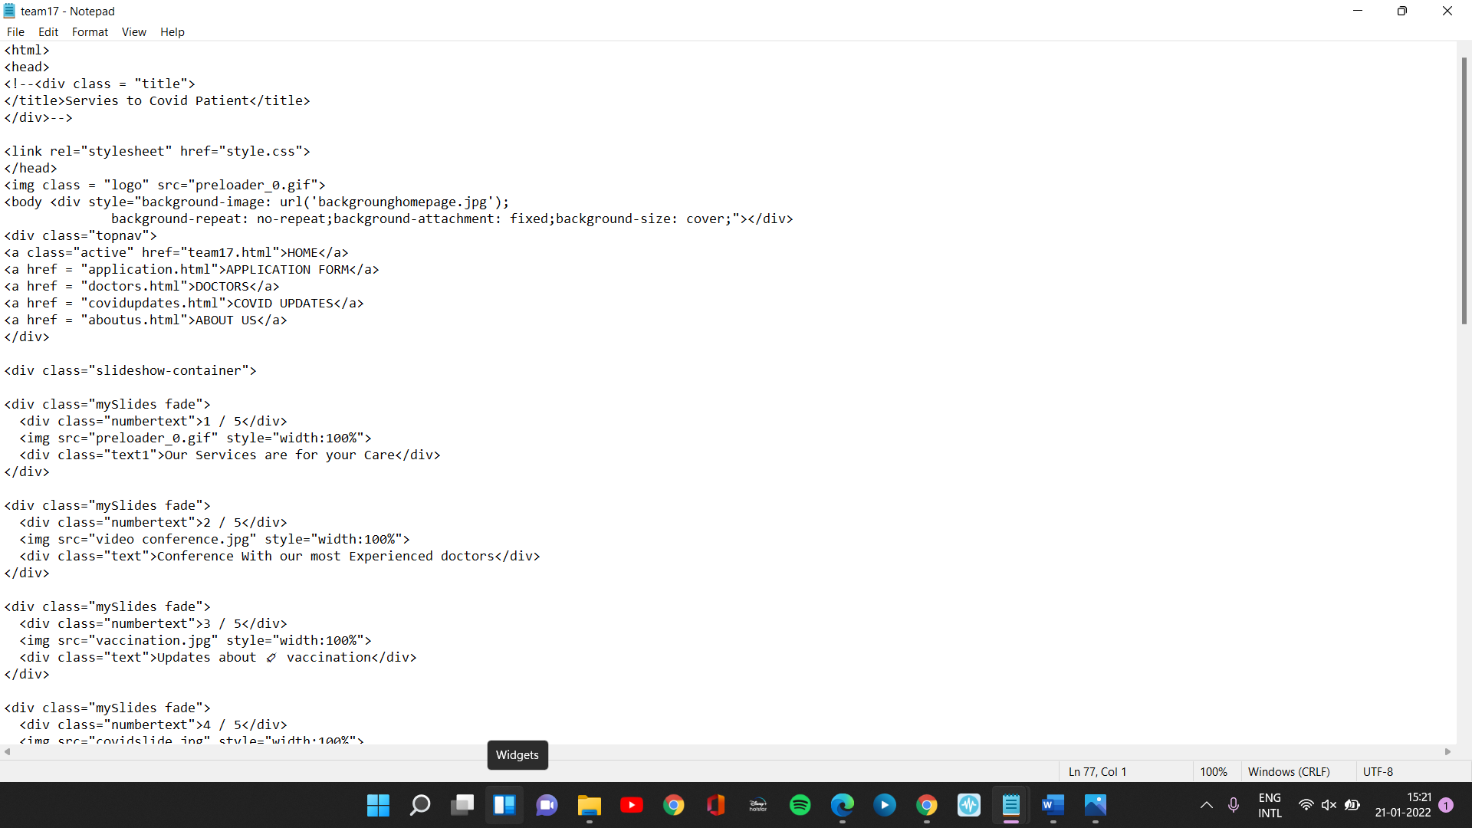

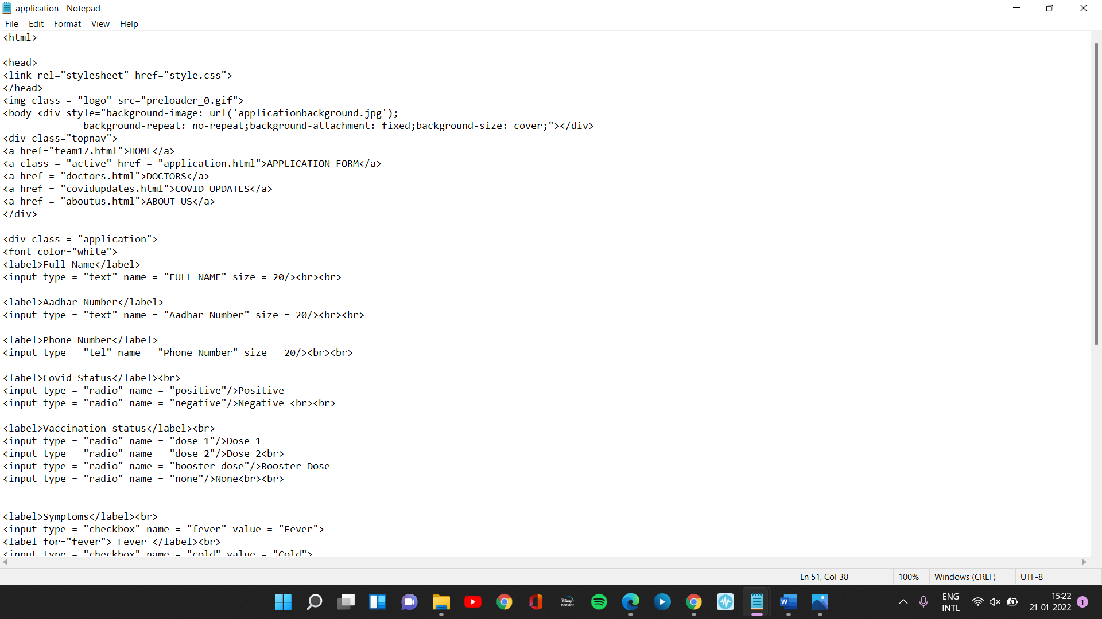

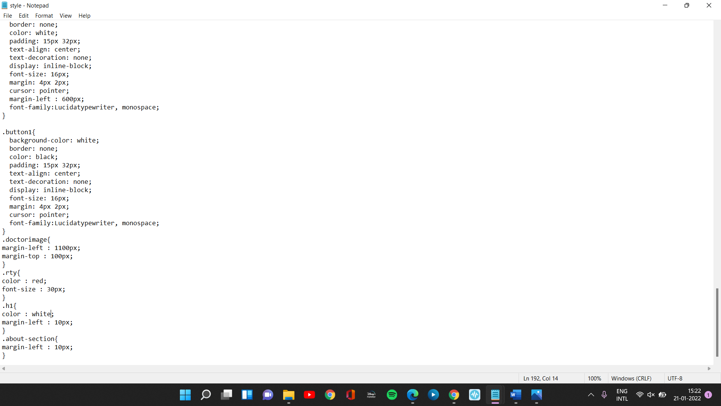

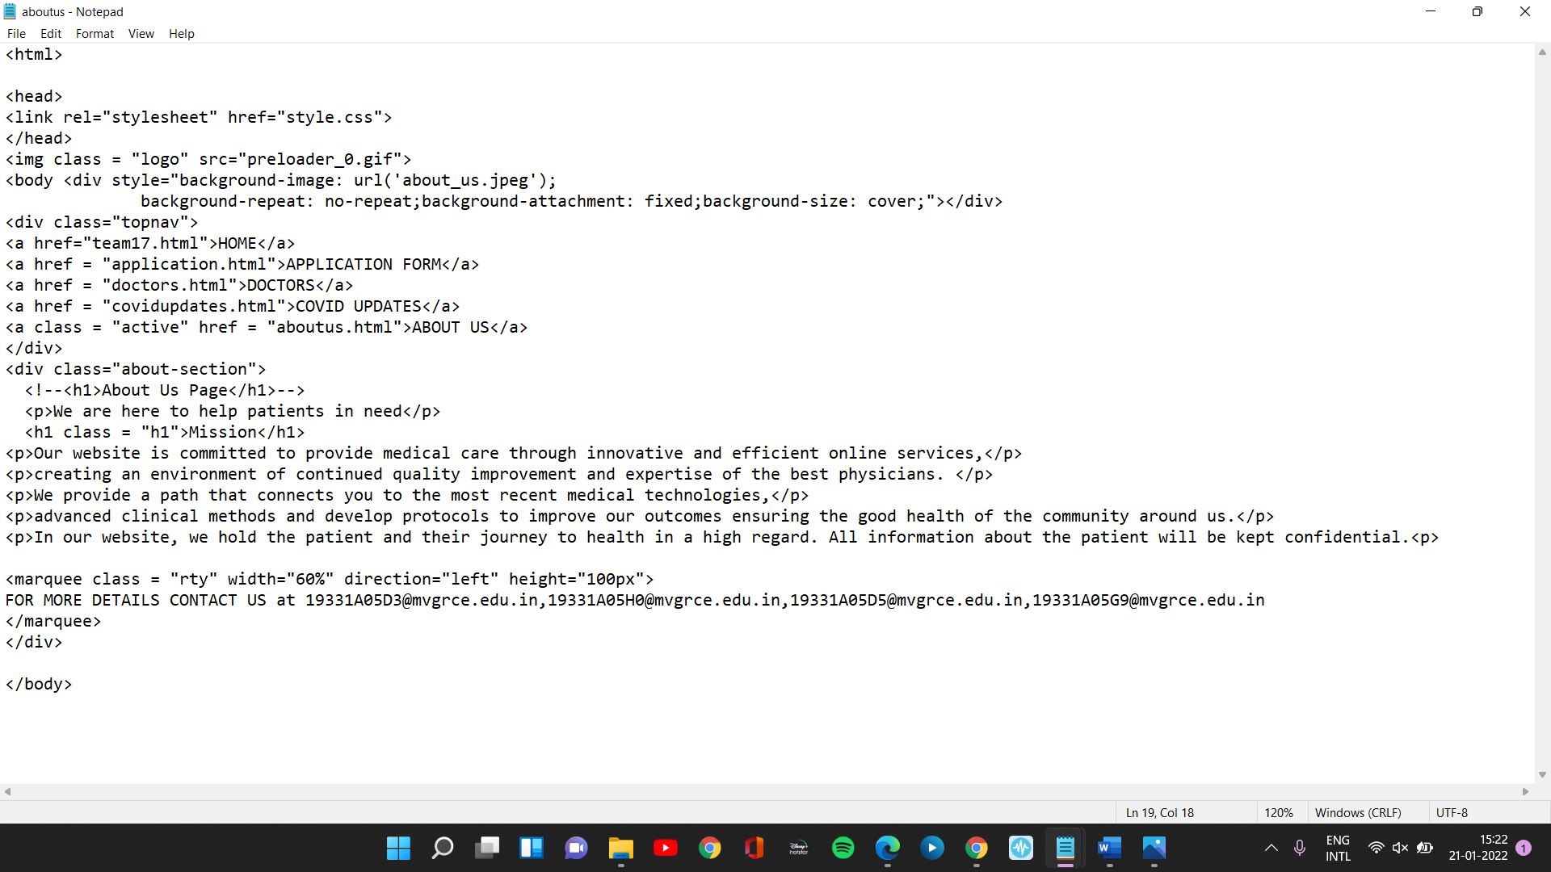

**DATABASE OF HOSPITAL:**

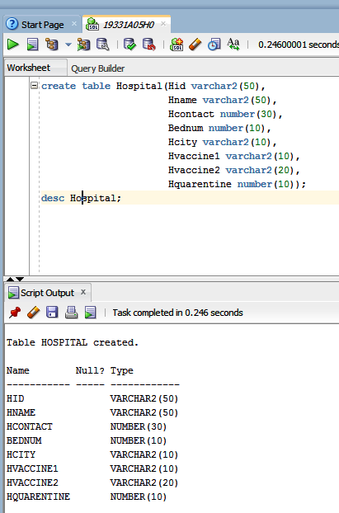

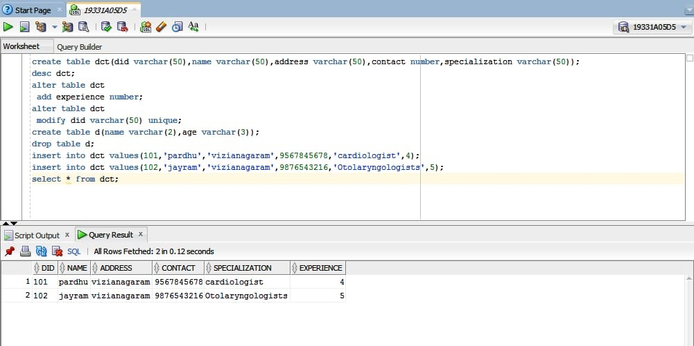

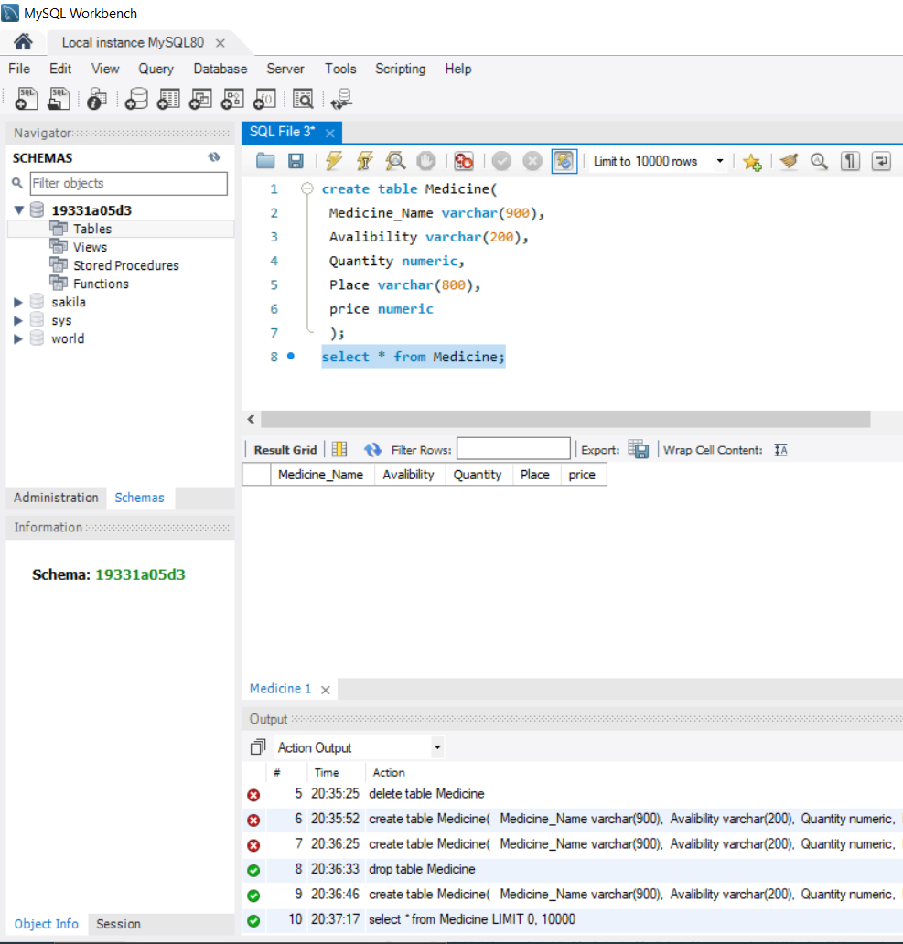

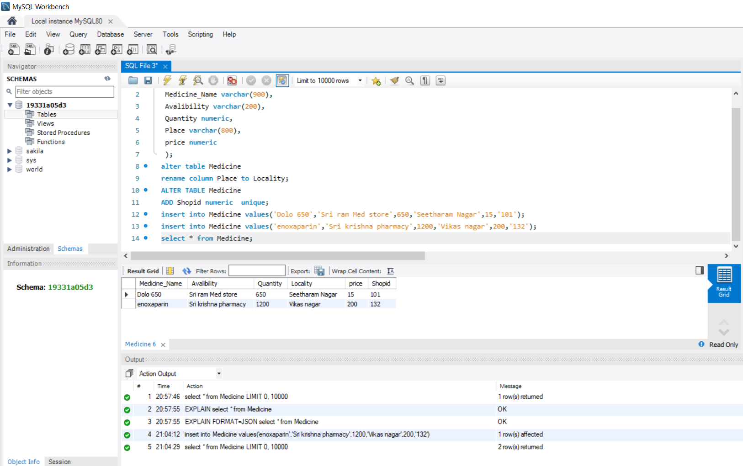

**WEBPAGE OUTPUT:**

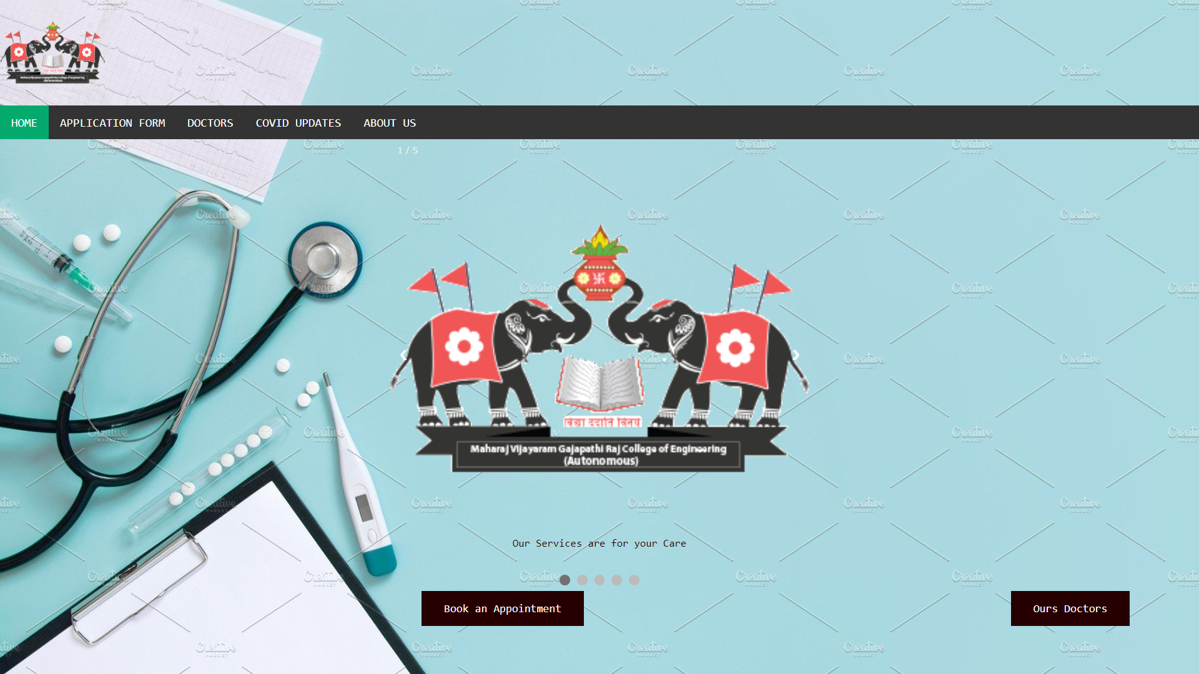

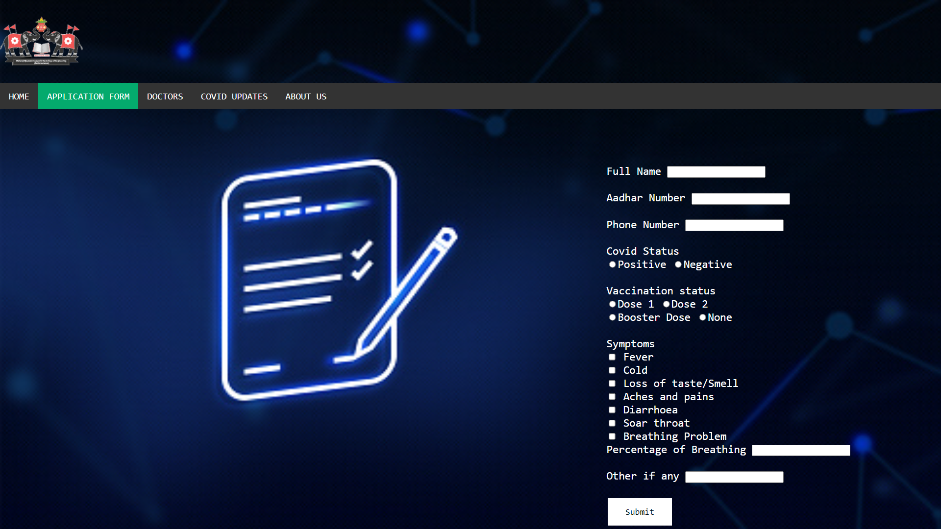

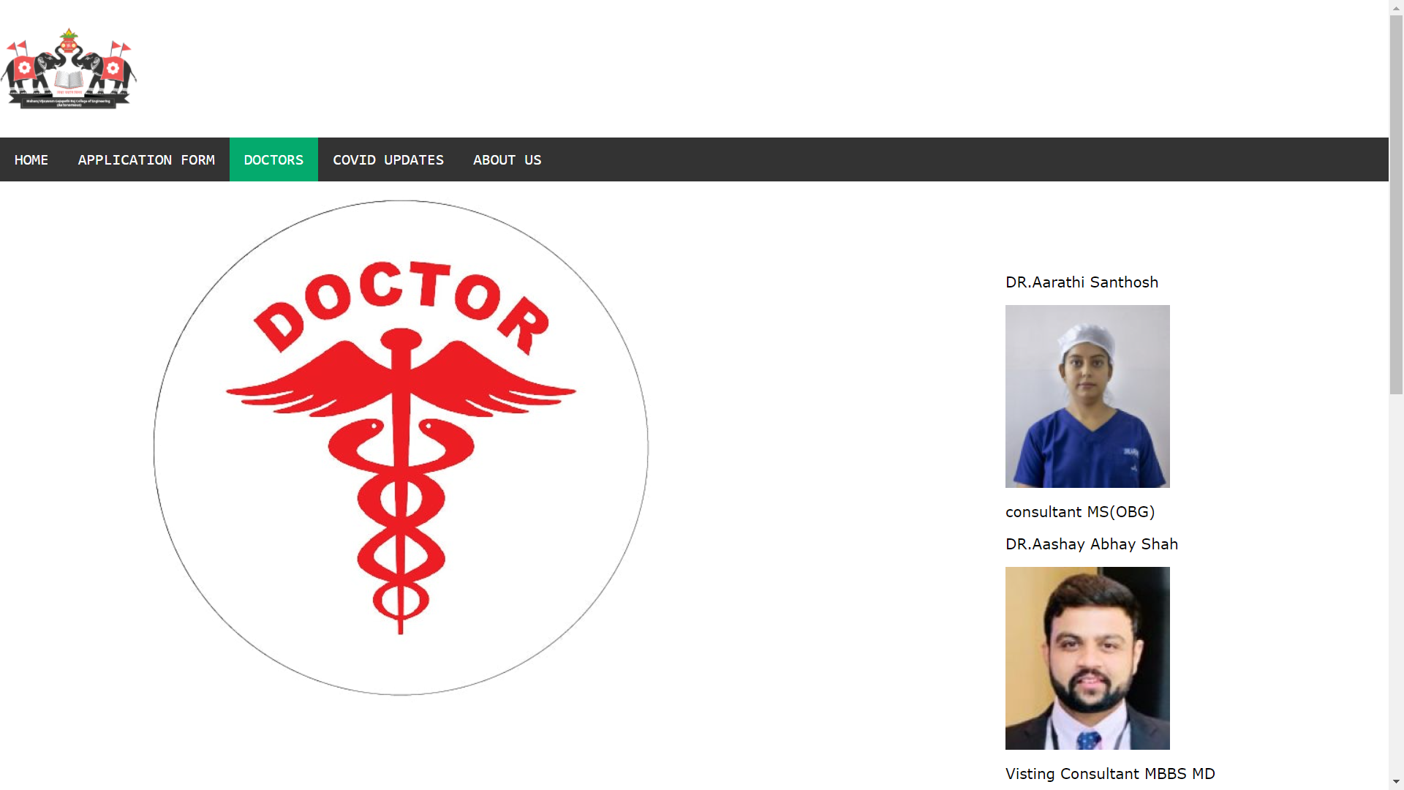

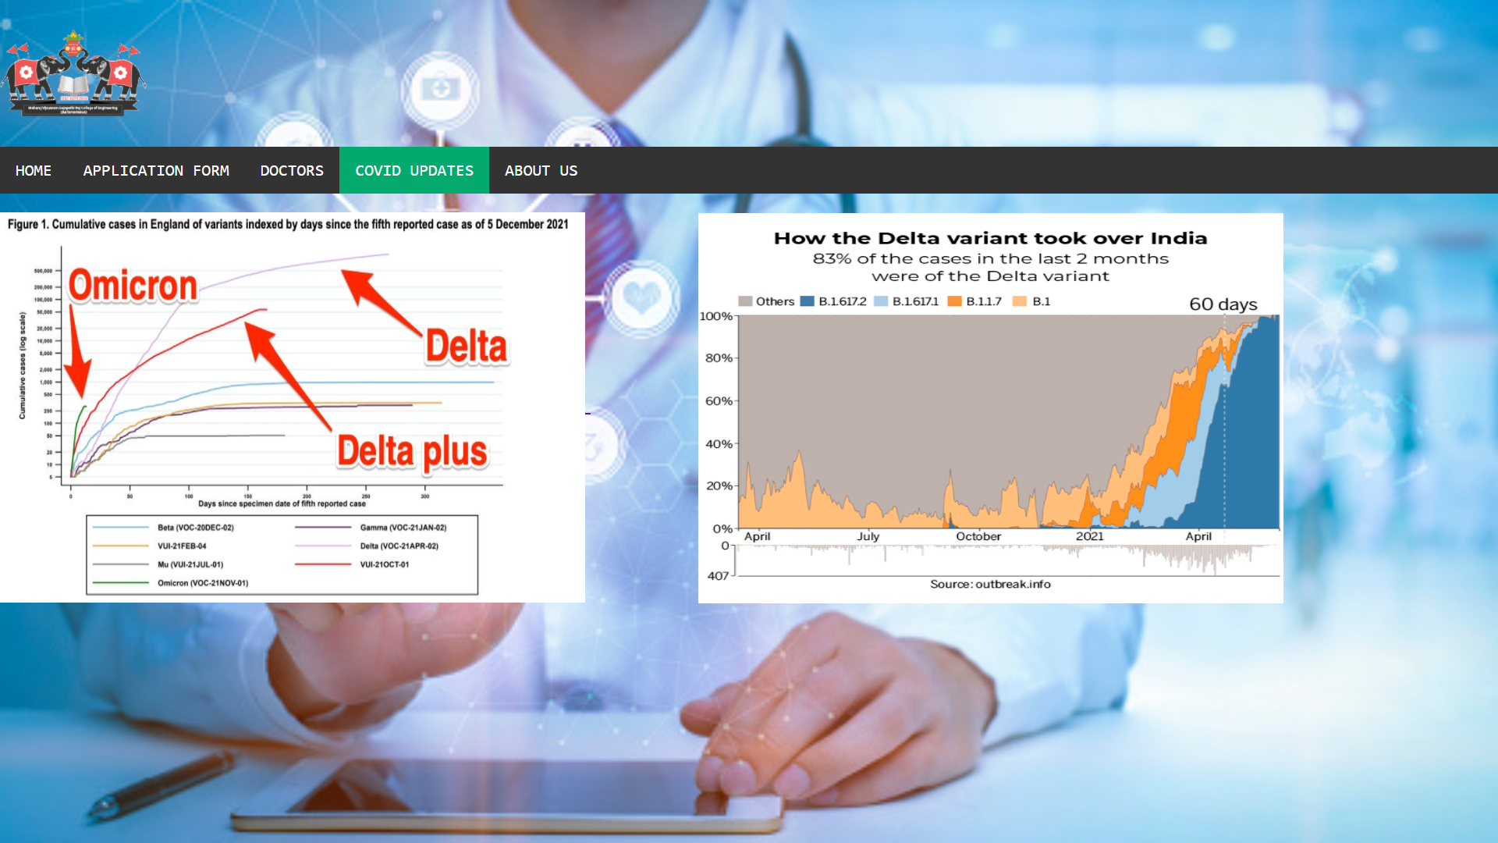

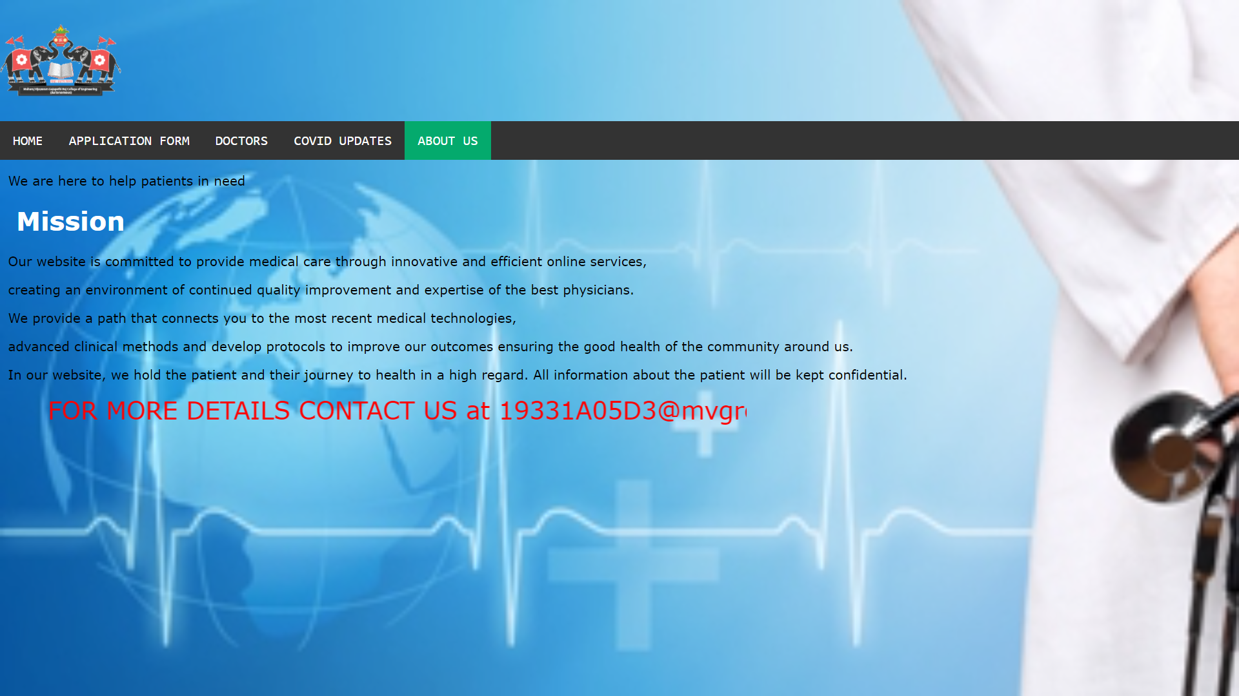

**Conclusion**

The most recent evidence published in this early period of the outbreak for health care providers, this study was conducted to identify the role of telehealth during COVID-19 outbreak. By undergoing several literature research we came to know about problems people faced during pandemic through offline. We came across the need of an online service to know about hospital services. We provide easy access to patients with specialized doctors. This is also useful for people who live many miles from the nearest medical facility, telemedicine provides a way to meet with a doctor quickly. This study provides a comprehensive systematic review solely exploring the potentials of telehealth during the COVID-19 pandemic. As the COVID-19 epidemic scales exponentially across the world, calls for expanded use of telehealth as innovative solutions, clearly highlight unmet needs in the world healthcare system.

**Project Outcome**

Telehealth has the potential to address many of the key challenges in providing health services during the outbreak of COVID-19. Also, telehealth can help us avoid direct physical contact and minimize the risk of COVID transmission and finally provide continuous care to the community. By this website some people are following the precautionary measures that are specified to stay away from this covid and it leads to a better public health outcome. Through this website the whole people came to know the prevention methods rather than management of the diseases. Not only covid patients but also normal patients may take help of this website to know about what services that the hospital are providing. From this project we can say online services are very important for the covid patients by knowing which hospital is providing our required needs. Telehealth services help provide necessary care to patients while minimizing the transmission risk of COVID-19, to healthcare personnel (HCP) and patients. Finally, from this project we will be able to help the covid patients who need hospital service may take help of this online services that is provided by this website.

**References**

https://www.cdc.gov/coronavirus/2019-ncov/hcp/telehealth.html

h<ttps://www.cdc.gov/coronavirus/2019-ncov/global-covid-19/essential-health-s>ervices.html

https://www.nhs.uk/nhs-services/gps/video-consultations/

https://www.seminarsonly.com/Engineering - Projects/Computer/digitalization-of-hospital.php

<https://www.who.int/emergencies/diseases/novel-coronavirus-2019/question-and-answers-hub/q-a-detail/coronavirus-disease-%28covid-19%29-variants-of-sars-cov-2?gclid=EAIaIQobChMI1KTdgfK_9QIVCJpmAh1R0whkEAAYAiAAEgKpOfD_BwE>